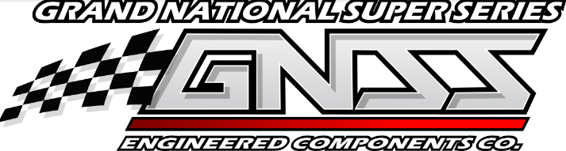

Grand National Super Series
2022 RACE PARTICIPANT INFORMATION

CAR NO.______

DRIVER`S Last Name________________________First Name______________________
ADDRESS_________________________________________________________________
City _______________________ State______ Zip_________ Date of Birth______________
Primary Phone Number ________________________ (Circle One) Cell Home Work
EMAIL_______________________________________________________
Emergency Contact________________________________Phone____________________

1099 Income Tax Form:  Driver - Driver’s Soc. Sec #___________________________
Choose One  Owner - Owners SSN or FEIN#________________________
Owner’s Last Name_______________________First Name_______________________
Address_________________________ City______________State_____Zip__________

AGREEMENT
Contract: I am an Independent contractor assuming all responsibility for money and prizes received as a result of my activities and participation including without eliminating, income tax, FICA, State taxes, workers compensation and withholding taxes. I am not an employee, servant, or agent of the Grand National Super Series.
Benefits: I agree that myself, my executors and assigns will be entitled only to the benefits of the Competitor Accident Policy procured by the Grand National Super Series for accidental injuries which are the result of external violent and visible means sustained in Grand National Super Series events. The foregoing stall constitute the limit of liability of the Grand National Super Series for such injuries occurring to me at any Grand National Super Series event provided proper notification is given.
Compliance: I agree to abide by all rules, procedures, and regulations of the Grand National Super Series now published or hereinafter modified. In consideration of the acceptance by the Grand National Super Series of this agreement, I recognize my obligation to the public and the Grand National Super Series, which posts the prize money and conducts the events.
Advertising Release: I consent to the use of my name, pictures of myself and my car for publicity, advertising and endorsements both before and after events, and relinquish any rights to photos, video or broadcast taken in connection with events. I consent to the publication or sale of such photos as the Grand National Super Series so desires.
Release & Waiver: I acknowledge that by signing the release and waiver at each event, in exchange for admittance to restricted areas, by so signing the release and waiver, I have waived legal rights, to sue for injuries, including death, and acknowledge the potentially dangerous nature of activities adjacent to restricted areas.
I HAVE READ AND FULLY UNDERSTAND THIS AGREEMENT. I AGREE TO ABIDE BY ALL TERMS OF THIS AGREEMENT AND THE REQUIRMENTS OF ALL THE RULES OF THE GRAND NATIONAL SUPER SERIES.

